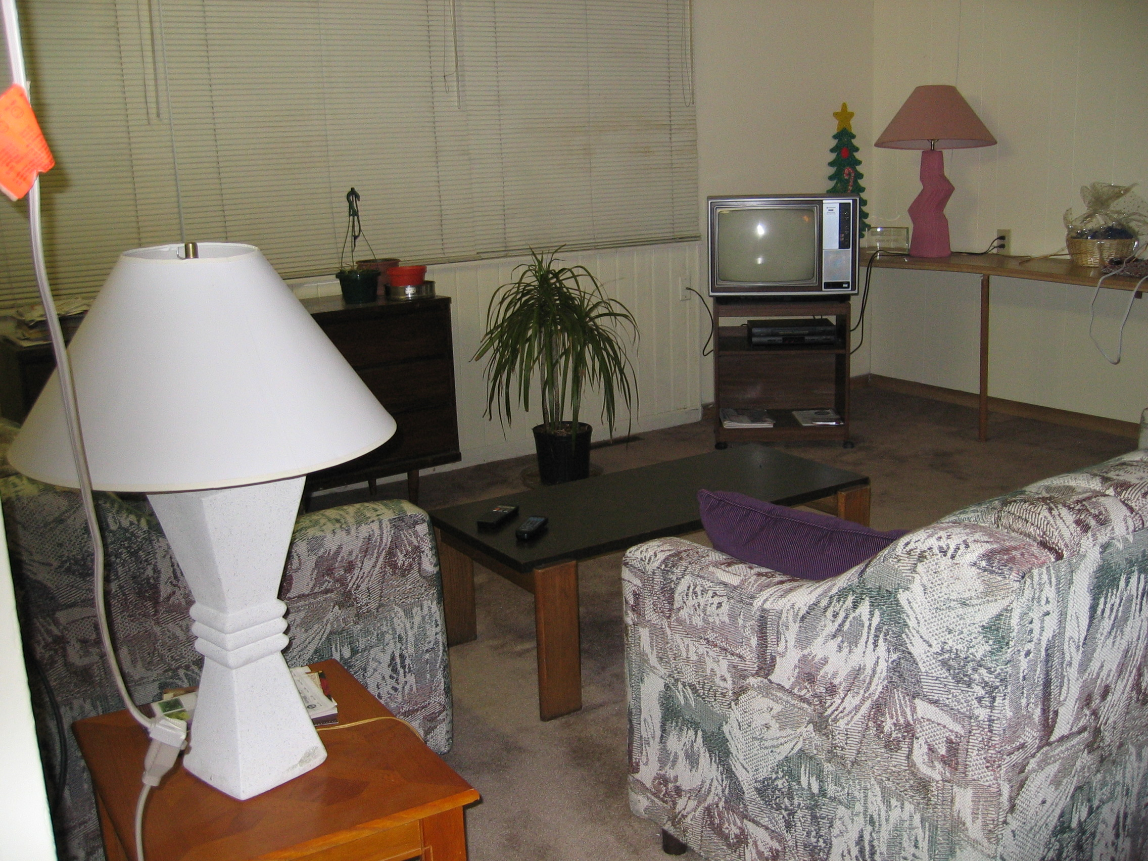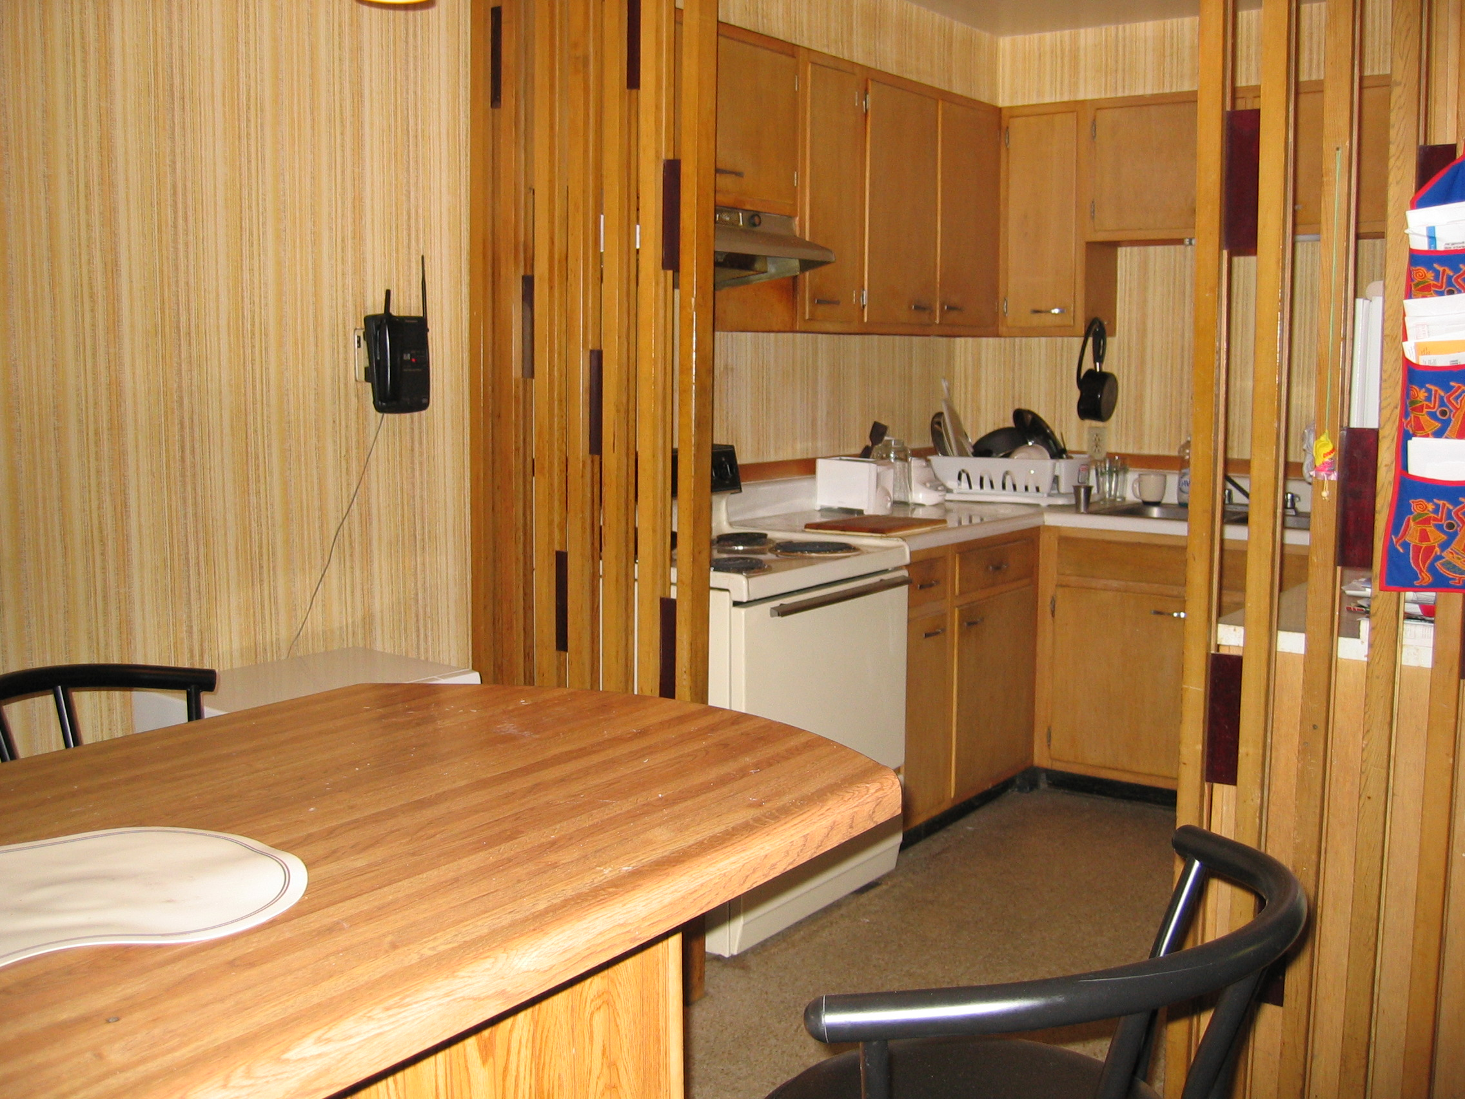

SUBLEASE AVAILABLE for 240$ per person!!!!!!
2 BEDROOM APARTMENT (JAN ’04 – AUG ’04)
508 E.Stoughton, #102

5 MINUTES FROM DCL!!!!
Intersection of Sixth and Stoughton, Lease ends on Aug 8th 2004 and can be renewed.

Apartment fully furnished, well maintained & in good condition
Rent is further negotiable!

Contact: Rashmi / Sindhura , 217-260-1553 / 217-390-0513, jyothi@uiuc.edu, bandhaka@uiuc.edu

